**RAT Program Proposal and Planning**

**Proposal**

For this year’s Rich Assessment Task, I propose to have a classic tank game where two players battle against waves and waves of enemy tanks to protect their home base. Each level will have a different map that would be customizable. This means that anyone at anytime could make a map for this game.

**Screen Layout**

This game will be very similar to a game with this kind of screen:

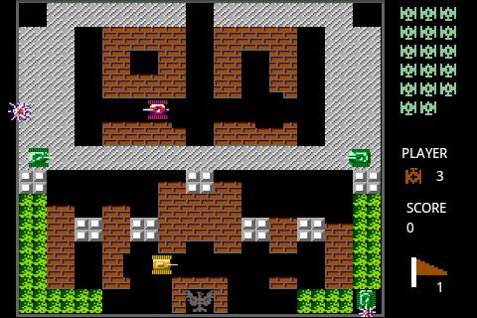

**Calculations and Methods**

This game will require numerous calculations and methods. The ones that are essential would include:

* Converting a 2D array of strings to a tank map
* Methods to return the coordinates of the tanks, the bullets, and the upgrades to see if they hit each other.
* Methods to tell tanks to move in all four directions.
* Checking for whether the tank is out of bounds of the screen or is in an invalid position on the map.
* Method to fire a bullet from a tank.
* Methods to calculate what to do for an enemy tank (A.I.).

**Pseudo-Code**

IF in between levels

DRAW level

ELSE

IF all enemies are dead

In between levels = true

IF player is alive

Determine if player hits the bullet. IF hit, decrement hitpoints, bulletAlive = false

Determine if player hits a upgrade, IF hit, act on upgrades

IF pressedUp

moveUp

etc. for all directions

IF screen doesn’t contain player OR player isn’t on an accessible part of map

moveBack

IF pressedFire

Fire

Do the same for the second player

Spawn enemies

FOR all of the enemies

IF the enemy is alive

Determine if enemy hits the bullet. IF hit, decrement hitpoints, bulletAlive = false

IF the enemy wants to move in this direction

Move

IF screen doesn’t contain enemy OR enemy isn’t on an accessible part of map

moveBack

IF the enemy wants to fire

Fire

Spawn upgrades

Move the bullets

IF bullet hit non-bullet-accessible part of map

Bullet disappears

FOR all parts of map

DRAW them

FOR all enemies

DRAW them

FOR all upgrades

DRAW them

FOR all players

DRAW them

FOR all bullets

DRAW them